Scanned by CamScanner

Scanned by CamScanner

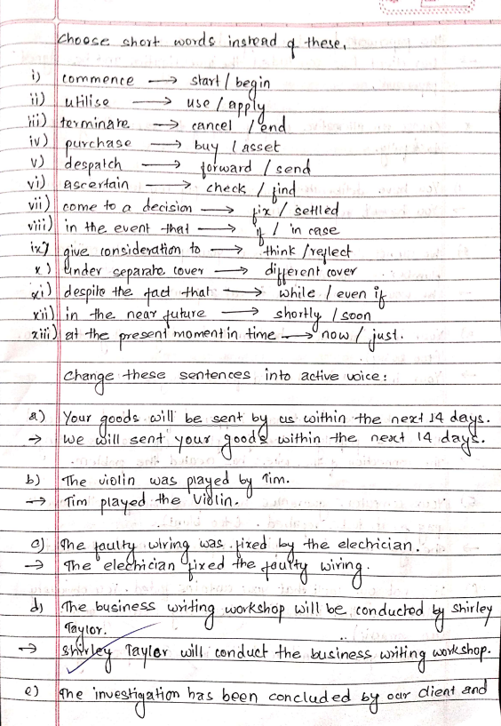Scanned by CamScanner

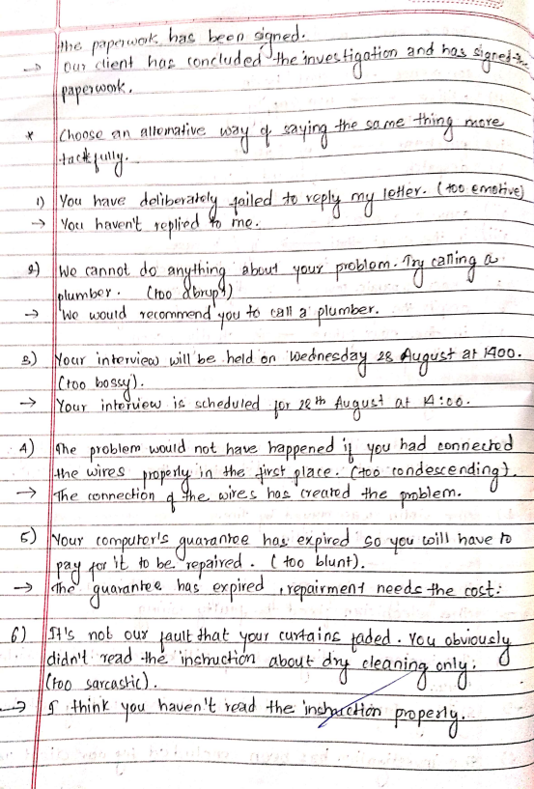Scanned by CamScanner

Scanned by CamScanner

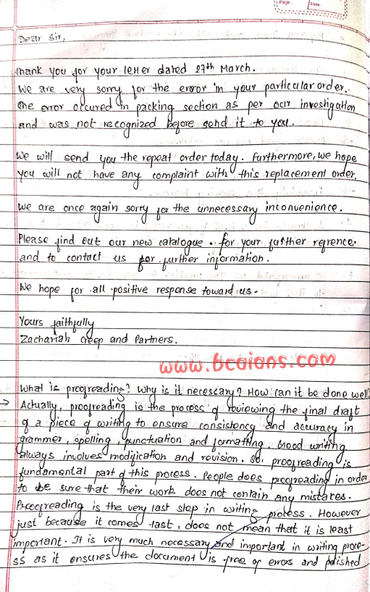Scanned by CamScanner

Scanned by CamScanner

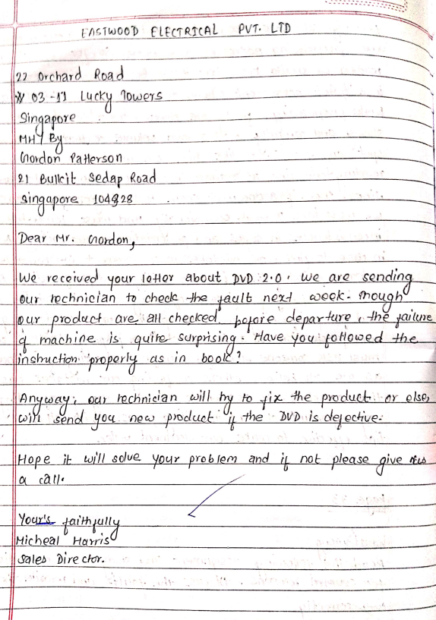Scanned by CamScanner

Scanned by CamScanner

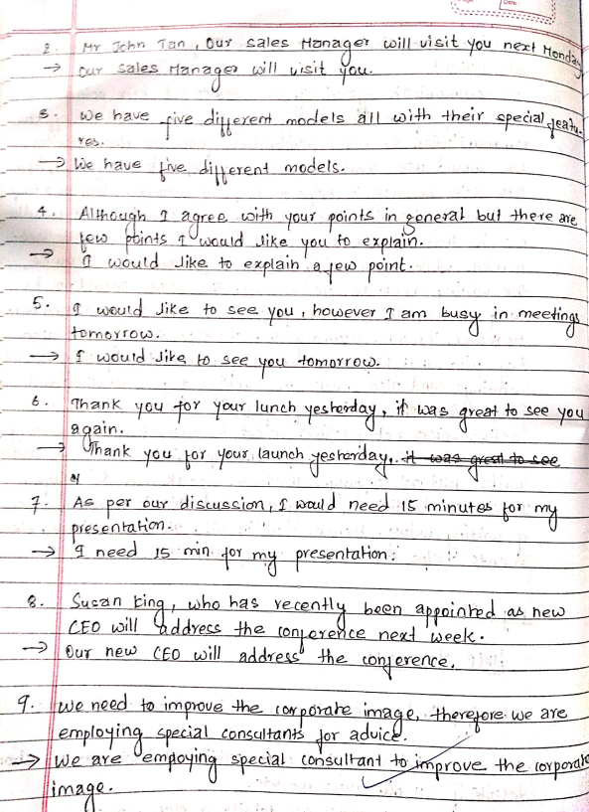Scanned by CamScanner

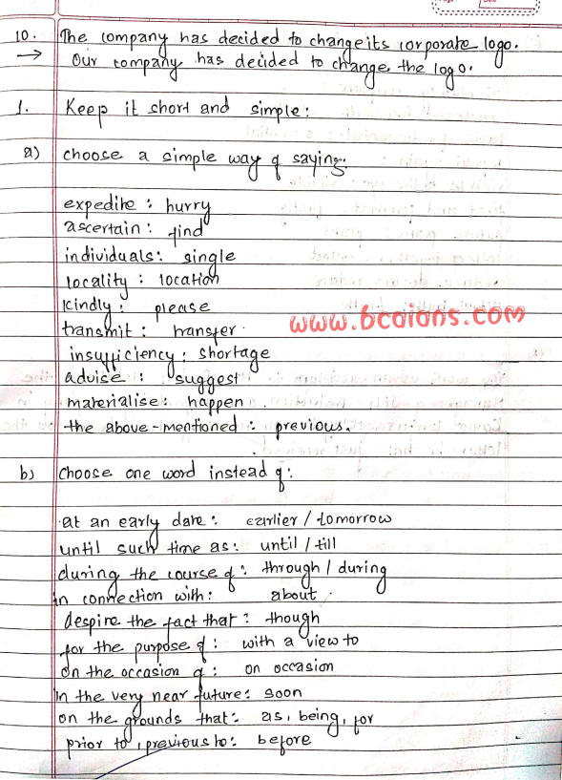Scanned by CamScanner

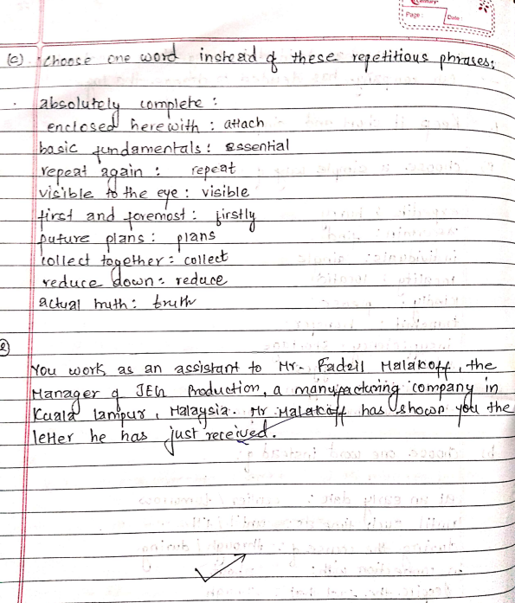Scanned by CamScanner

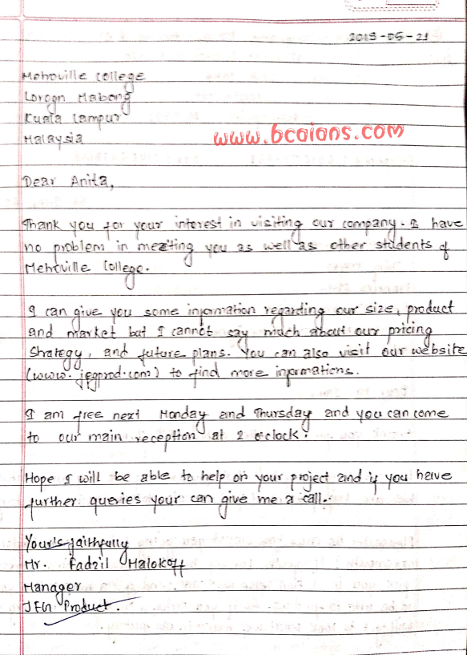Scanned by CamScanner

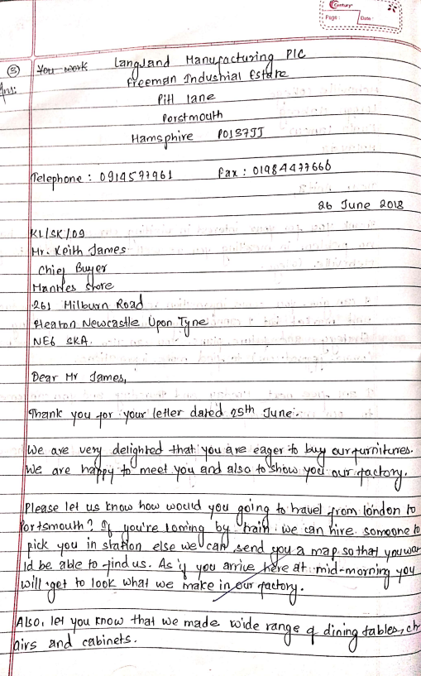Scanned by CamScanner

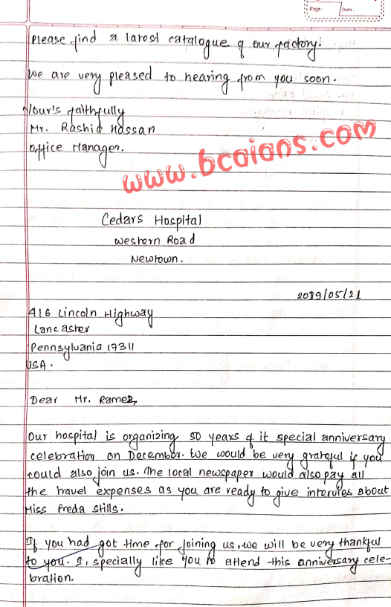Scanned by CamScanner

Scanned by CamScanner

Scanned by CamScanner

Scanned by CamScanner

Scanned by CamScanner

Scanned by CamScanner

Scanned by CamScanner

Scanned by CamScanner

Scanned by CamScanner

Scanned by CamScanner

Scanned by CamScanner

Scanned by CamScanner

Scanned by CamScanner

Scanned by CamScanner

Scanned by CamScanner

Scanned by CamScanner

Scanned by CamScanner

Scanned by CamScanner

Scanned by CamScanner

Scanned by CamScanner